Sudhir Singh,
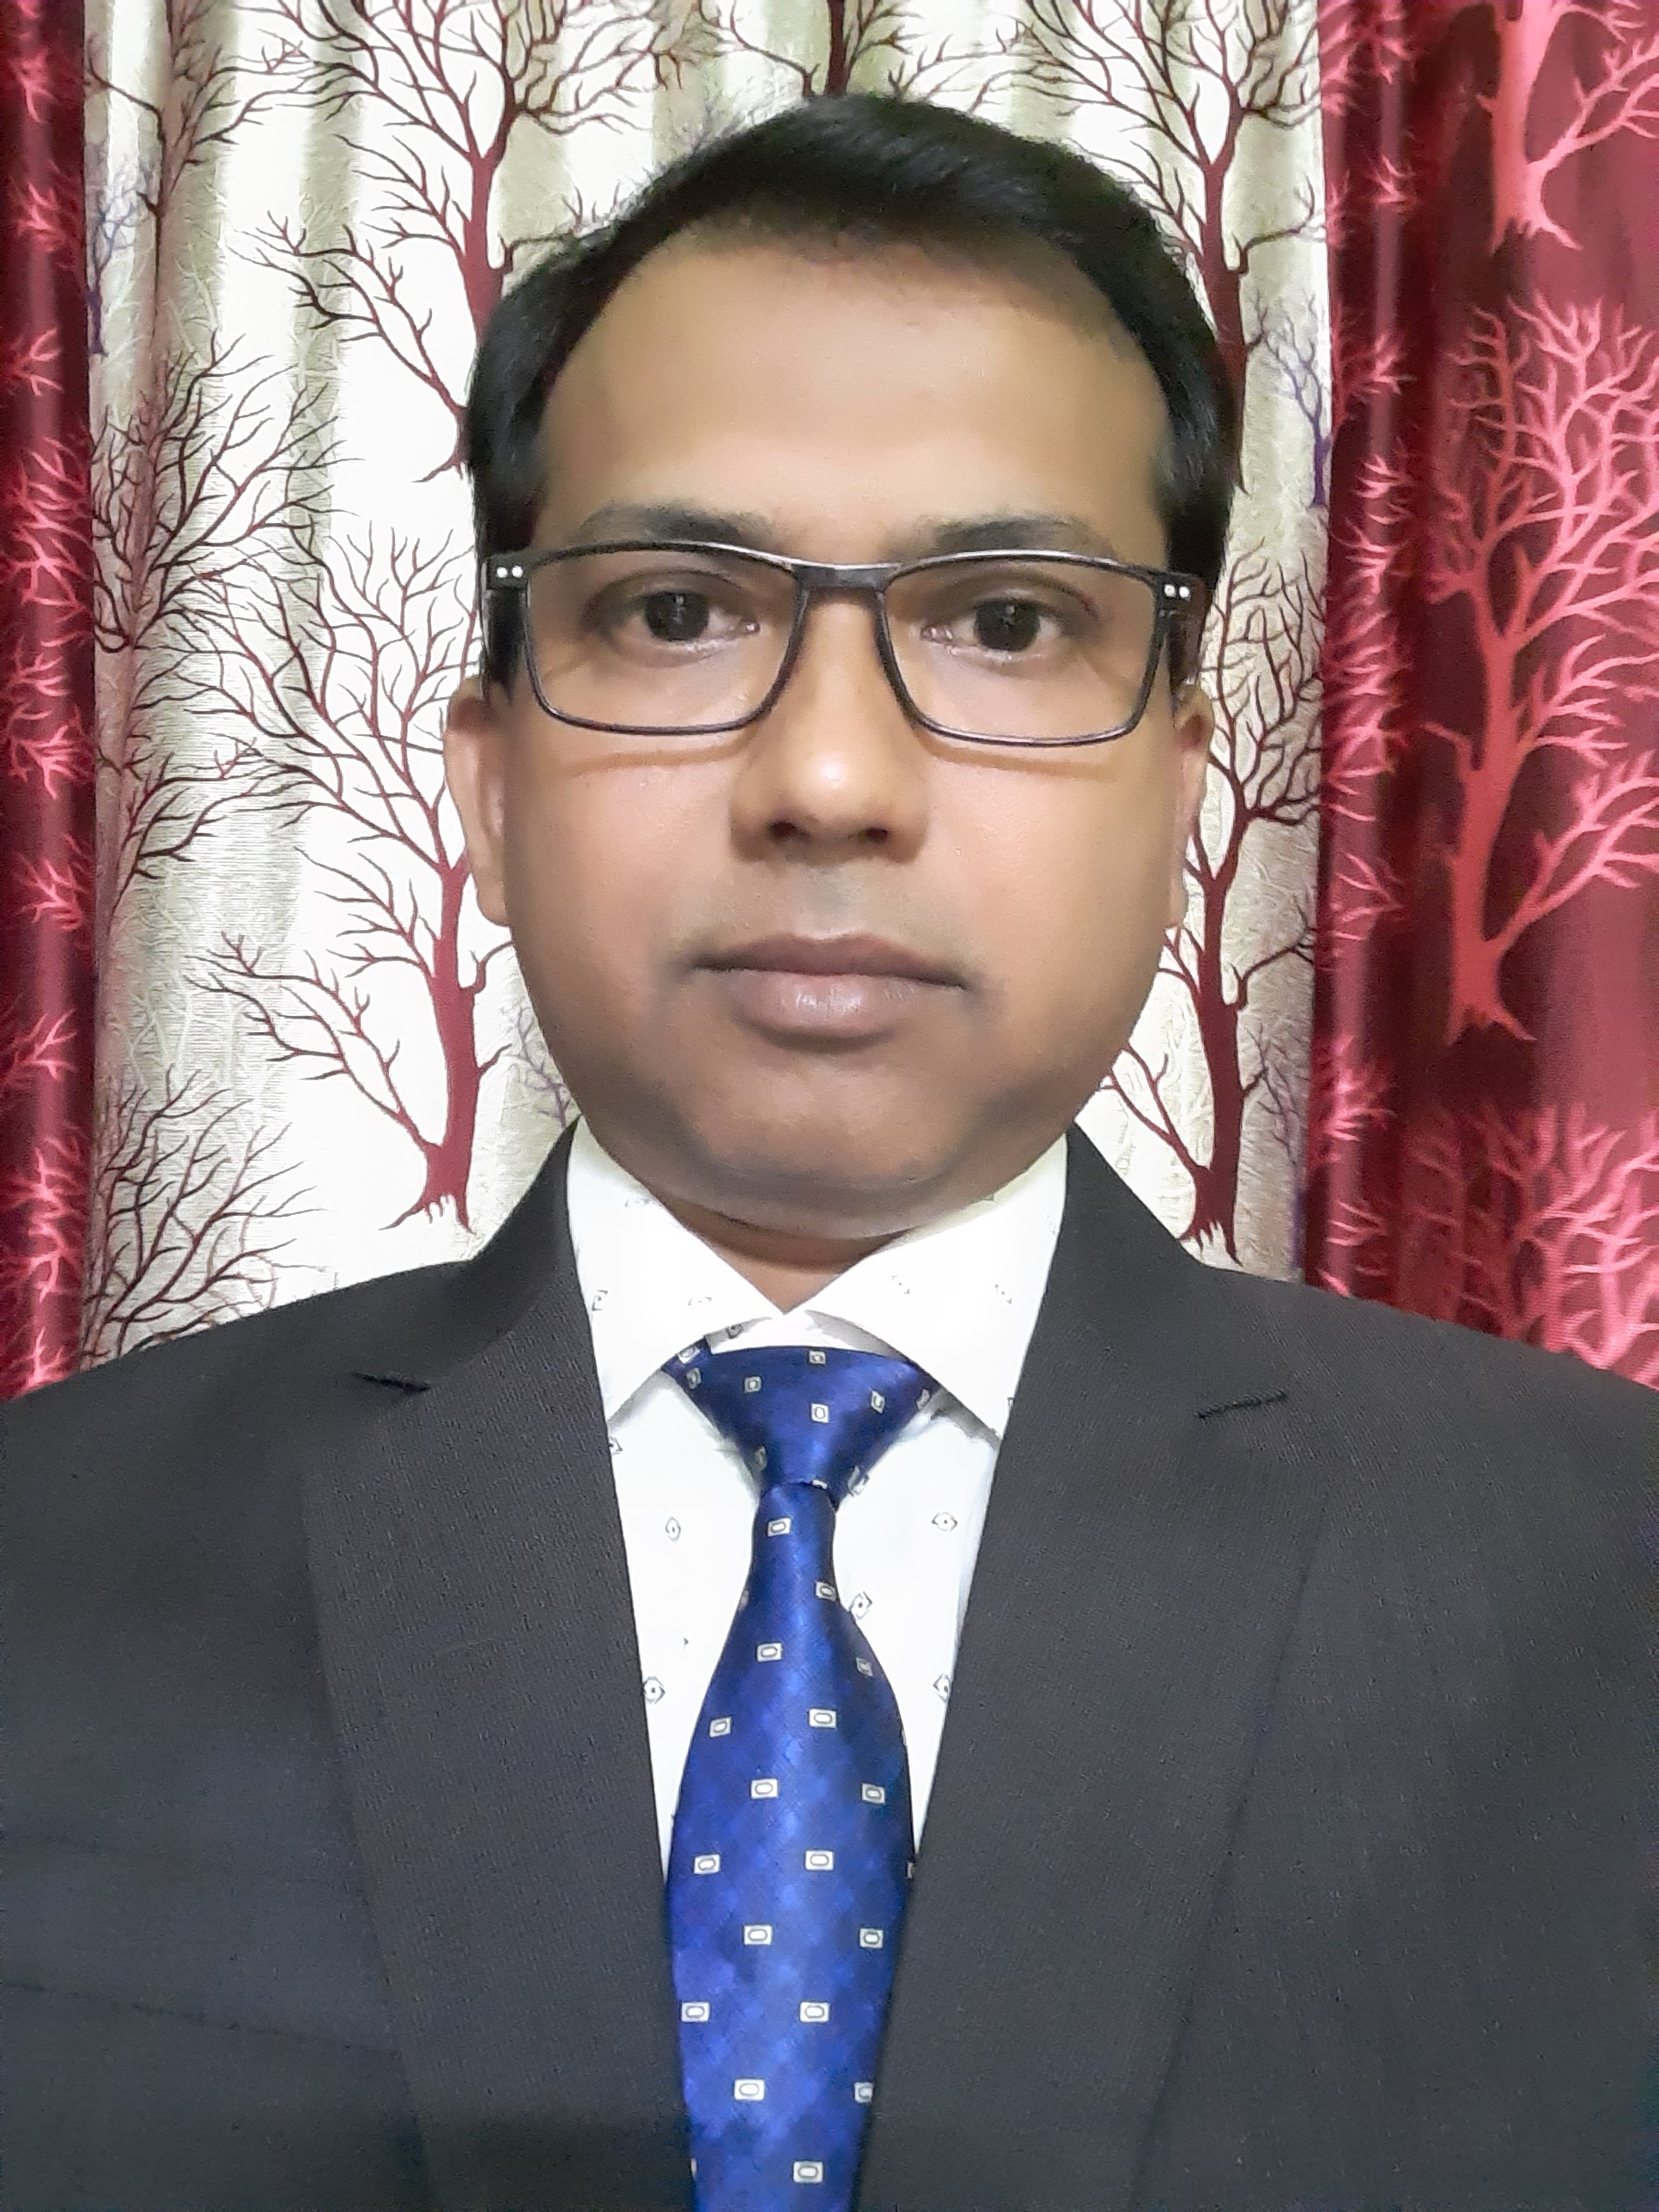

Assistant Professor,
Department of Electronics And Instrumentation
Engineering Unsiet VBS,Purvanchal University ,Jaunpur

Life Discipline-- Completing All The Assign Work In The Given Time,
Respect Every Faculty And Staff Irrespective Of Rank Or Cadre.

Qualification:-- B.Tech In Electronics And Instrumentation Engineering From
M.J.P Rohilkhand University Bareilly U.P.

M.Tech In Instrumentation And Control Engineering From
Sant Longowal Institute Of Engineering And Technology
Sangrur (Punjab)

- INTEREST & SPECIALIZATION:

- Instrumentation And Control
- Power Plant Instrumentation

Paper Published-
- Analysis Of A Boost Converter Using Closed Loop System [ISSN:2249-1945] GJCAT, Vol. 2(2),2012, 1178-1183
- Comparative Simulation & Analysis Of 2-PSK Spreading Transceiver [ISSN:0975-5462] IJEST, Vol. 4 No.06 June 2012
- Continuous Mode Of Sepic Converter Using Separately Excited DC Motor Load [ISSN:2249-1945] GJCAT, Vol.2(1), 2012, 941-944
- Operation Of Single User Vs. Multi User 2-PSK Spreading Transceiver System [ISSN:2229-5216] IJEST, Vol.5 No.4,2012

Book Published-
CO-Author of book Advanced Power Electronics.

Assistant Professor In Contract From 2011 Till Date.

Experience-

2 Years Working Experience As A Teacher In Ahilya Bai College Of Management & Information Technology (ACMIT) Sultanpur.
Training-
1 Year Apprenticeship Training In U.P.P.C.L. Shakti Bhawan Lucknow.
5 Days Training In Faculty Development Program On Entrepreneurship Under Vision-2030 Organised By Institute Of Entrepreneurship Development, U.P., Lucknow.

Participation-
1-Participated In HR Conclave’15 Under Industry Interface Programme On February 20, 2015.
Attended More Than 10 FDP, Short Term Course , Industries And Tour Visit 3+

